
LINKS 3.0

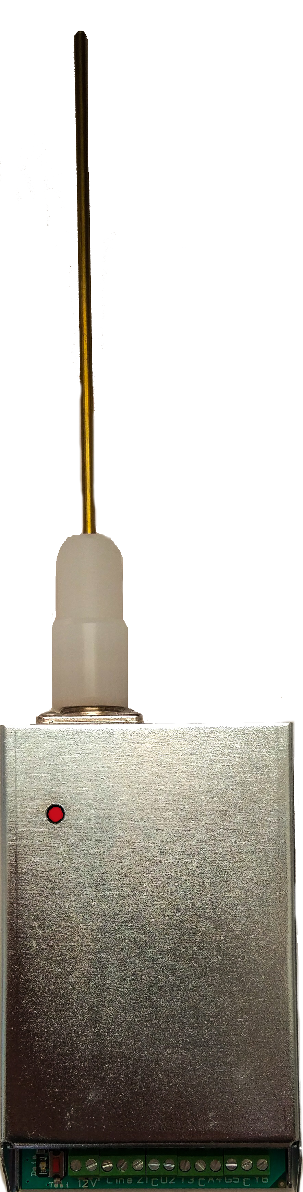
- Power supply: 10.5V-15V;
- Current consumption: 1.2A @ 5W and +13V supply;
- Output power: Low 2W; High up to 6W;
- Frequency range: VHF version: 130–175MHz; UHF version: 400–490MHz;
- Channel spacing: 12.5KHz;
- Frequency deviation: 2-2.5KHz;
- Up to 8 operating frequencies in the range (can operate at all frequencies simultaneously);
- Ability to work with a set of algorithms for the transmission mode of the different frequencies;
- Buffer memory: 64 events;
- Rate of data transmission: 400 to 1200 b/s (depends on the protocol);
- Broadcasted radio protocols: PPE 1, LARS, LARS 1, INFORMER, KEL (could work simultaneously on all programmed radio protocols);
- Not necessary to program any event codes. The translation of the original DSC codes to protocols LARS/ LARS1, Informer and KEL is automatic. When used, the input zones are programmed any broadcasted from the transmitter codes to activate and deactivate them;
- Connects to control panel by: ComBus, telephone communicator (ContactID), PGM outputs, input zones and signals, ComBus + 4 zones, Contact ID + 6 zones.


PERSONAL PROTECTION-ELECTRONIC Ltd. 2016
www.dscbg.com

